B39SB Time and Frequency Signal Analysis

Week 1 Tutorial on Signals and Spectra

------------------------------------------------------------------------------------------------------------------------
Energy of 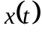 is 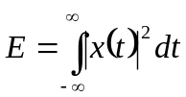. Power of a signal is 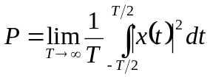
The bandwidth of a signal is the difference between the highest and the lowest frequencies of the spectral components of the signal. A signal is said to be a band-limited signal if the amplitude of its spectrum goes to zero for all frequencies beyond some threshold called the cutoff frequency.
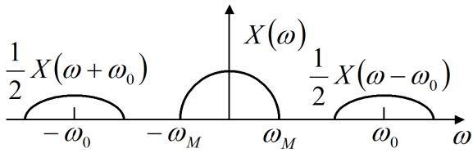
The Modulation theorem: if 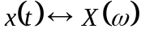, then 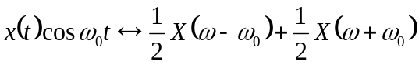
------------------------------------------------------------------------------------------------------------------------
P1. Find the power of a sinusoid 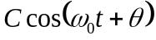 Ans. 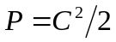

P2. Find the complex Fourier coefficients 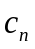 for the periodic signal 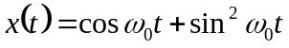.
Ans. . All the other coefficients are equal to zero.

P3. Find the Fourier transform of 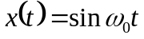 Ans. 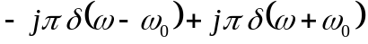

P4. A signal 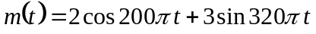 is ideally sampled at 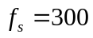 Hz. If the sampled signal is passed through an ideal low-pass filter with cutoff frequency of 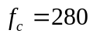 Hz, what frequency components will appear at the output? Justify your answer.
Ans. 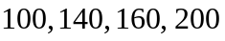-Hz components.

P5. A signal is ideally sampled at Hz. If the sampled signal is passed through an ideal low-pass filter with cutoff frequency of 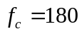 Hz, what frequency components will appear at the output? Justify your answer.
Ans. 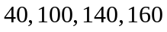 Hz components.

P6. Let 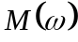 be the Fourier transform of a signal 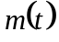. Find the Fourier transform of 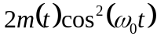. Ans.

P7. Find the frequency response of the network shown below
